**Java Databases GUI:**

**Bank Database Java GUI Screenshots:**

Main GUI Window:

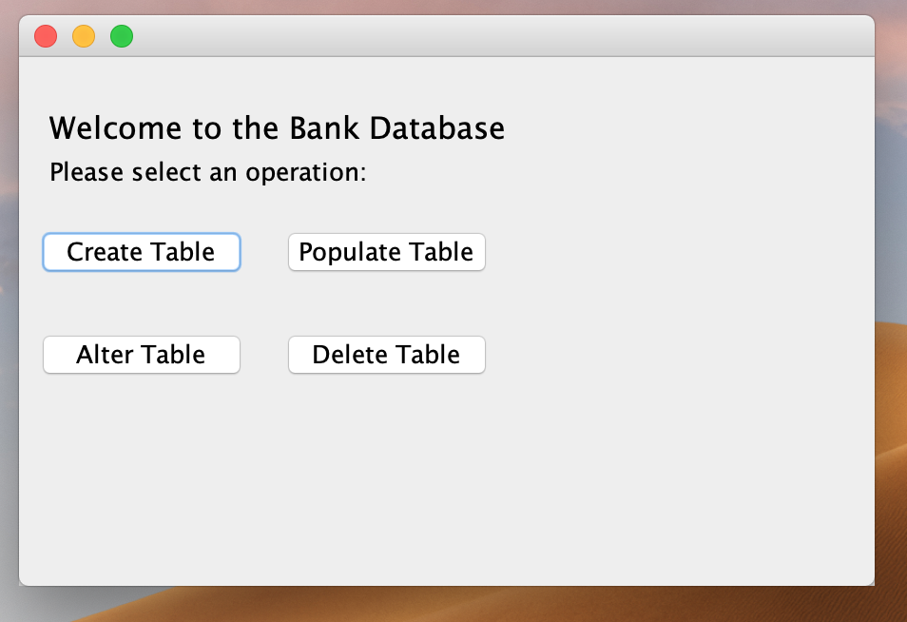

Clicking on Create Table creates new table RESERVE3:

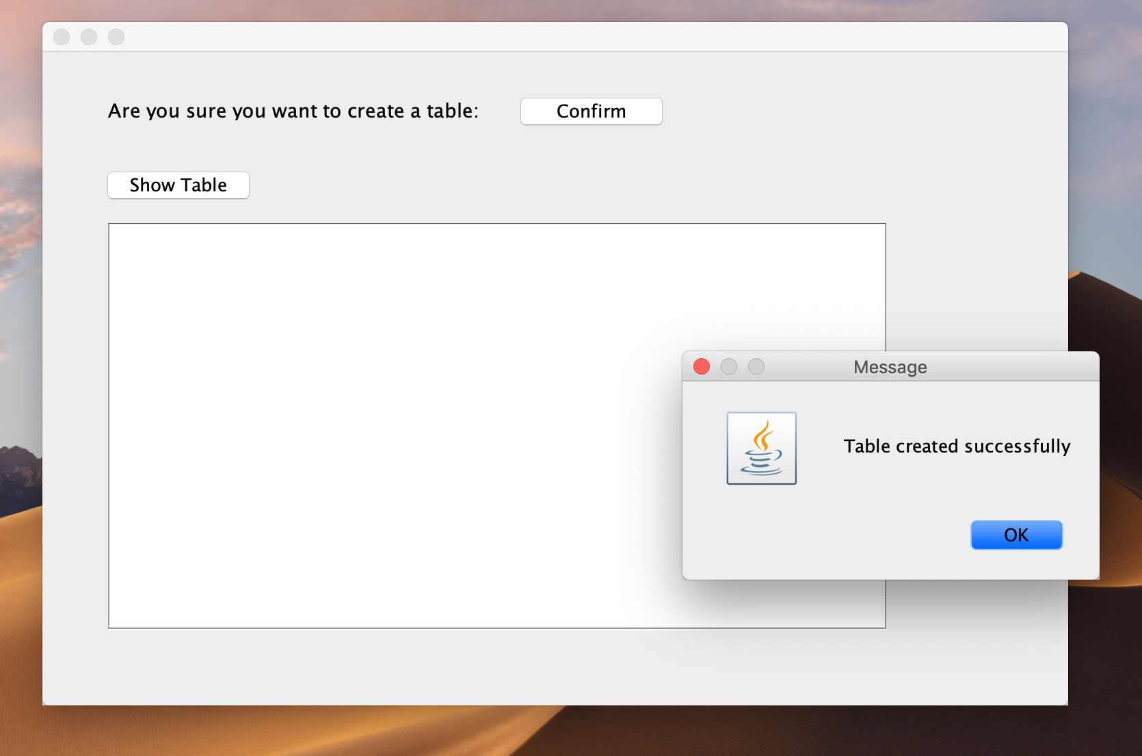

Preview the empty table (RESERVE3) by clicking Show Table:

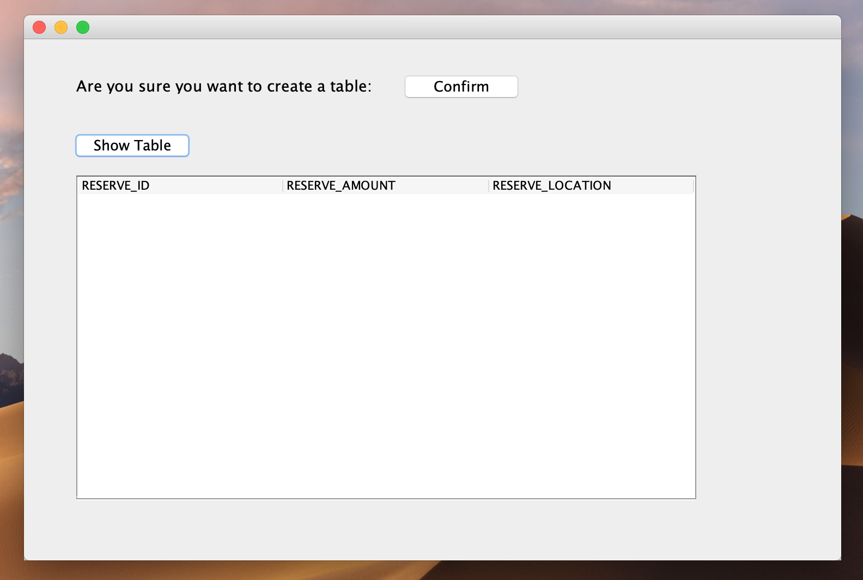

Insert values into the RESERVE3 by clicking Populate Table on the Main UI:

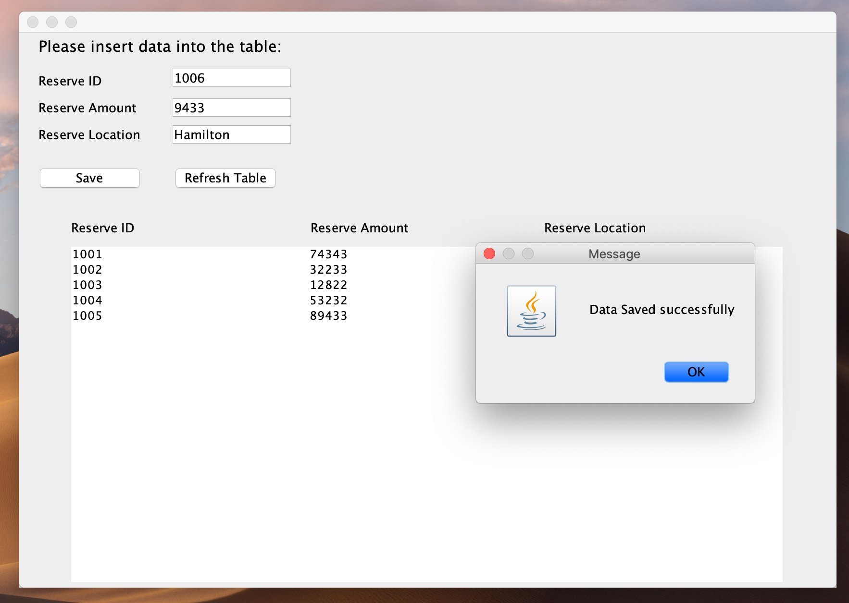

Checking SQL Developer to see that the table (RESERVE3) was created:

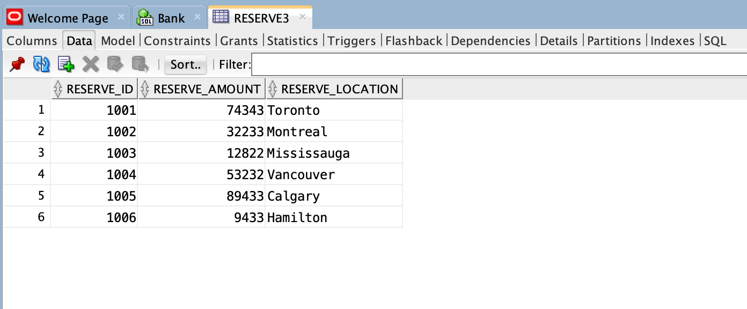

Altering the table (RESERVE3) by using Reserve ID as the input argument:

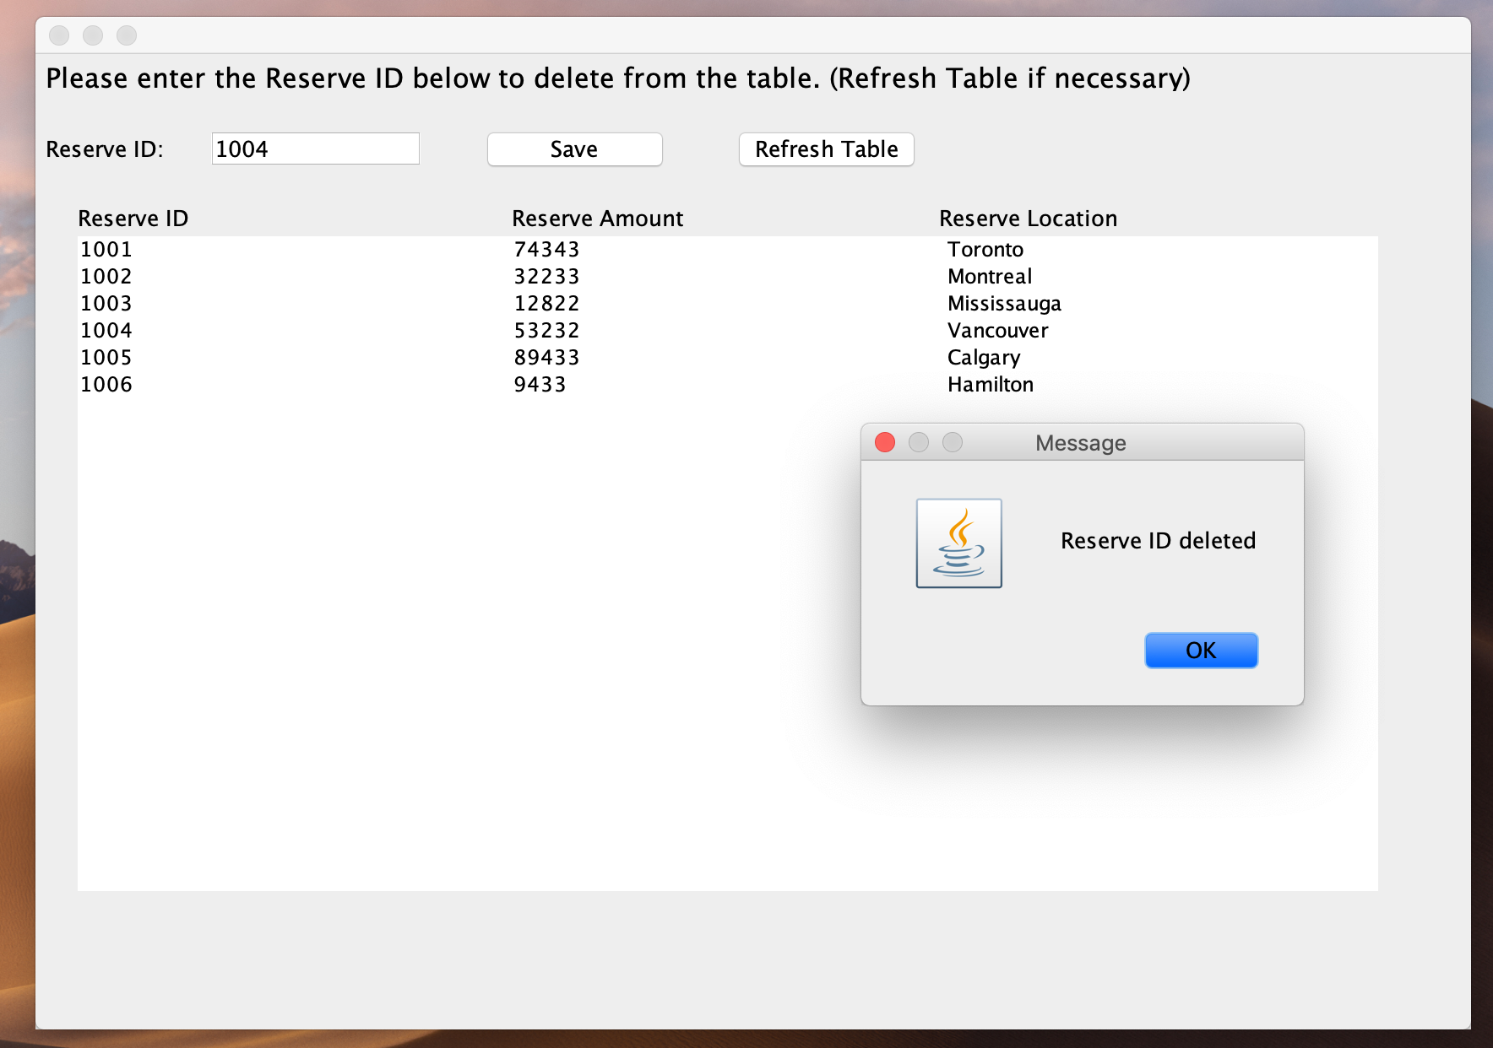

Refreshing Table after deletion of Reserve ID: 1004 and 1005 from the table:

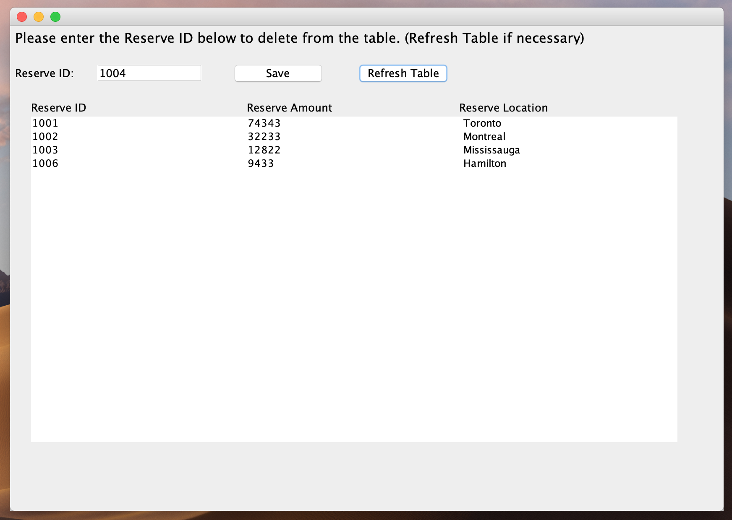

Dropping the table, RESERVE3 by clicking Delete Table from the Main UI:

